**Practical No 5**

**Time series forcasting**

**#Load Data AirPassengers**

>data("AirPassengers")

**#finding the class name**

> class(AirPassengers)

[1] "ts"

**#start of Time series**

> start(AirPassengers)

[1] 1949 1

**#end of Time series**

> end(AirPassengers)

[1] 1960 12

> frequency(AirPassengers)

[1] 12

**#The cycle of this time series is 12months in a year**

> summary(AirPassengers)

Min. 1st Qu. Median Mean 3rd Qu. Max.

104.0 180.0 265.5 280.3 360.5 622.0

**#the no of passengers distributed across the spectrum**

plot(AirPassengers)

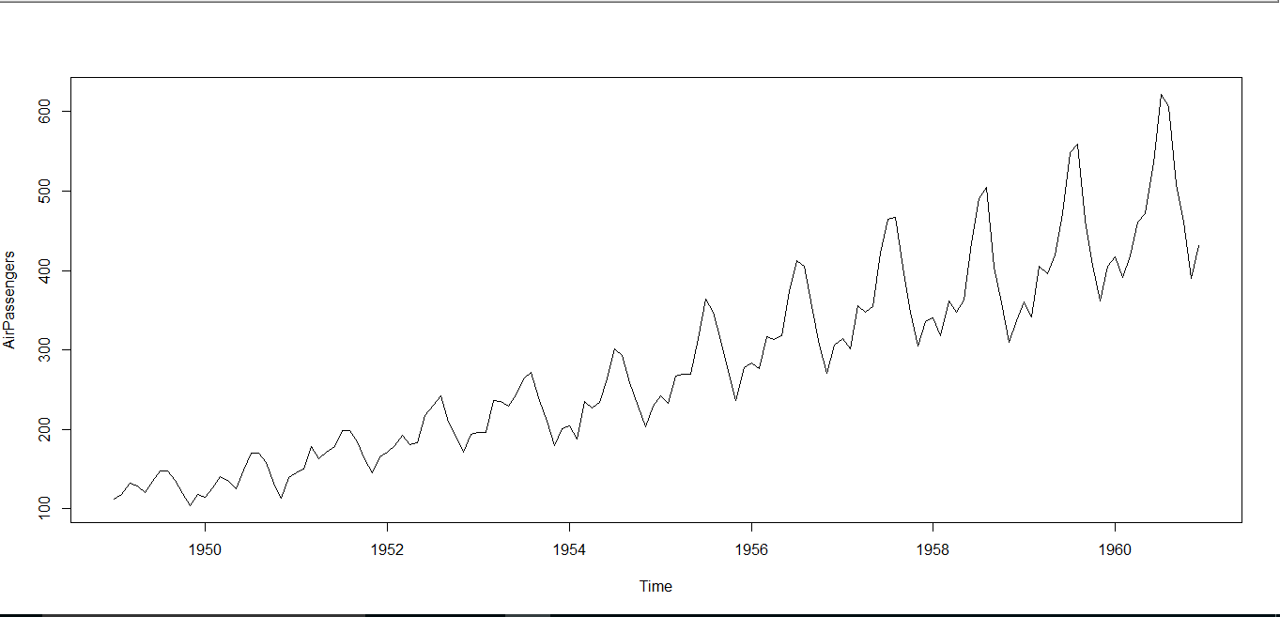

**#this will plot the time series**

> abline(reg=lm(AirPassengers~time(AirPassengers)))

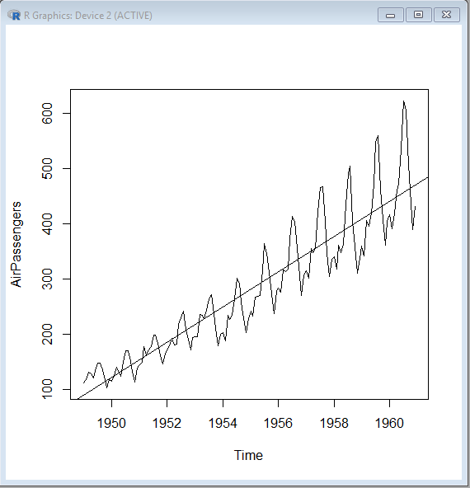

**#This will print cycle across years**

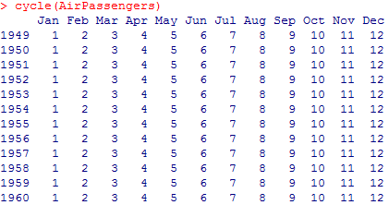

**#this will aggregate the cycles and display a year on year trend.**

> plot(aggregate(AirPassengers,FUN=mean))

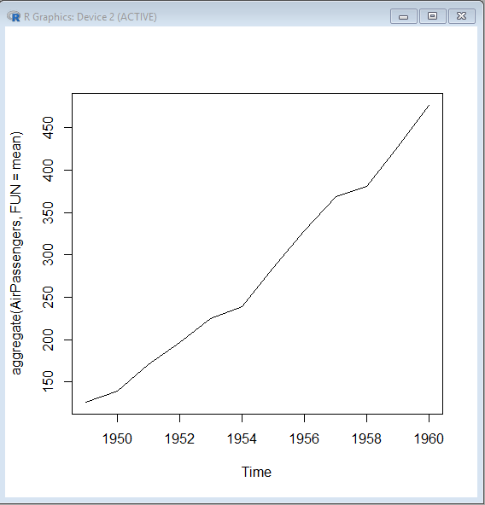

**#Box plot across months will give us a sense on seasonal effect**

> boxplot(AirPassengers~cycle(AirPassengers))

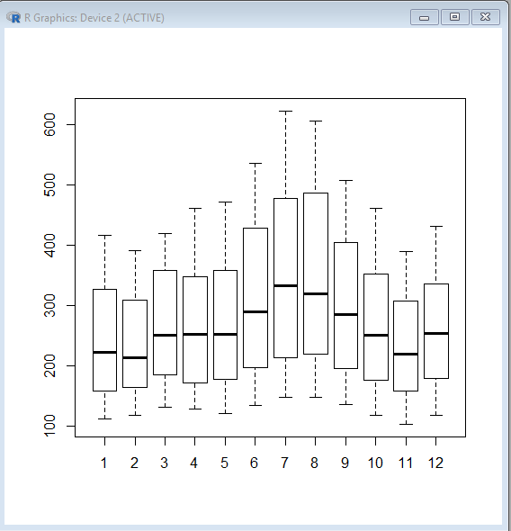

**Following are the ACF plots for the series:**

> acf(log(AirPassengers))

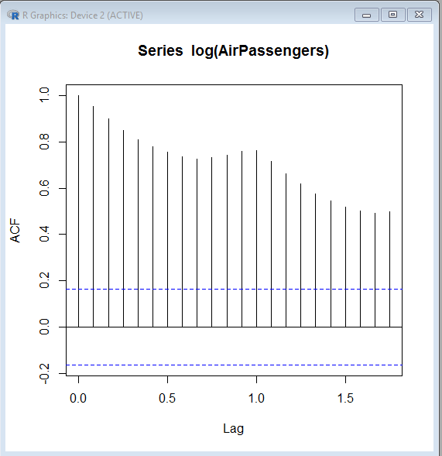

> acf(diff(log(AirPassengers)))

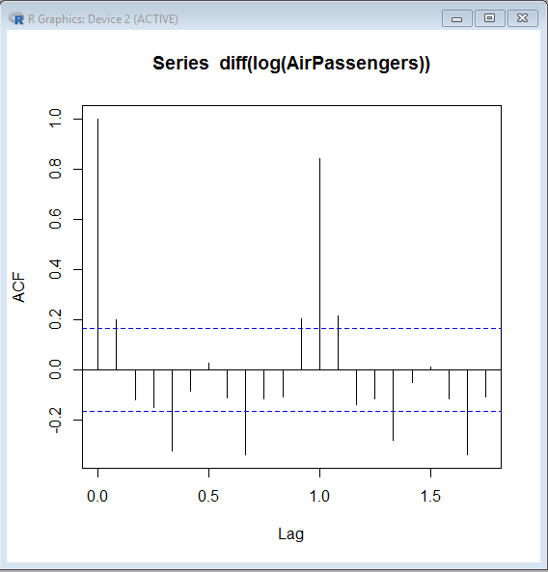

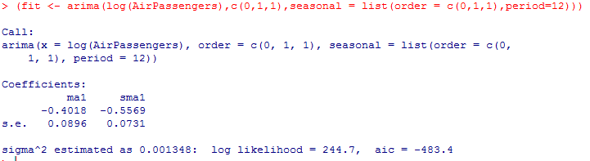

> pred <- predict(fit,n.ahead=10*12)

> ts.plot(AirPassengers,2.718^pred$pred,log = "y",lty= c(1,3))

